**PRACTICAL 3: Arrays**

**AIM:**

To write C++ programs demonstrating arrays.

**Theory:**

**One-dimensional array:** One dimensional array is also known as a list or a linear array. It consists of only one column or one row.

**Two-dimensional array:** A two-dimensional array consists of columns and rows. Each element of the two-dimensional array is referenced by its index values or subscripts. The index value of a two-dimensional array consists of two subscripts. One subscript represents the row number and the second subscript represents the column number.

**Q1. Write a C++ program to find the largest element of a given array of integers**

**CODE:**

#include <iostream>

using namespace std;

int main()

{

int n, i, max;

cout << "Enter the size of the array: ";

cin >> n;

int array[n];

cout << "Enter the numbers for the array: ";

for (i = 0; i < n; i++)

{

cin >> array[i];

}

max = array[0];

for (i = 0; i < n; i++)

{

if (array[i] > max)

{

max = array[i];

}

}

cout << "The biggest number in the array is " << max << endl;

}

**OUTPUT:**

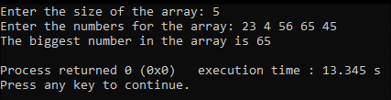

**Fig1. Output of program showing biggest number out of an array of given numbers**

**Q2. Write a C++ program to count the number of occurrences of a given number in an array of integers**

**CODE:**

#include <iostream>

using namespace std;

int main()

{

int n, i, query, count = 0;

cout << "Enter size of the array: ";

cin >> n;

int array[n];

cout << "Enter the numbers for the array: ";

for (i = 0; i < n; i++)

{

cin >> array[i];

}

cout << "Enter the number to be searched within the array: ";

cin >> query;

for (i = 0; i < n; i++)

{

if (array[i] == query)

{

count++;

}

}

cout << "The number of occurrences of " << query << " in the array is " << count << endl;

}

**OUTPUT:**

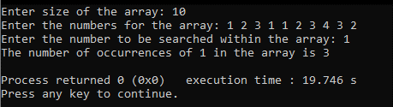

**Fig2. Output of program showing number of occurrences of a specified number in an array**

**Q3. Write a C++ program to display even number from an entered array**

**CODE:**

#include <iostream>

using namespace std;

int main()

{

int n, i;

cout << "Enter the size of the array: ";

cin >> n;

int array[n];

cout << "Enter numbers in the array: ";

for (i = 0; i < n; i++)

{

cin >> array[i];

}

cout << "The even numbers in the array are: ";

for (i = 0; i < n; i++)

{

if (array[i] % 2 == 0)

{

cout << array[i] << " ";

}

}

}

**OUTPUT:**

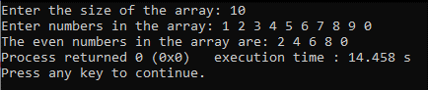

**Fig3. Output of program showing even numbers out of an array**

**Q4. Write a C++ program to accept 3x3 matrix and display the transpose of a given matrix**

**CODE:**

#include <iostream>

using namespace std;

int main()

{

int i, j;

int matrix[3][3];

cout << "Enter the value for the 3x3 matrix::\n";

for (i = 0; i < 3; i++)

{

for (j = 0; j < 3; j++)

{

cin >> matrix[i][j];

}

}

cout << "The transpose of the matrix is:\n";

for (i = 0; i < 3; i++)

{

for (j = 0; j < 3; j++)

{

cout << matrix[j][i] << " ";

}

cout << endl;

}

}

**OUTPUT:**

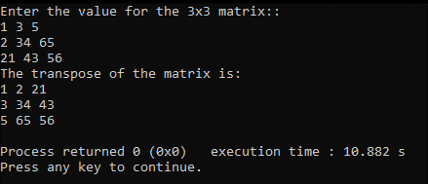

**Fig4. Output of transpose of a given matrix**

**Q5. Write a C++ program to accept two 3x3 matrix and display sum of the two matrices**

**CODE:**

#include <iostream>

using namespace std;

int main()

{

int i, j;

int matrix1[3][3];

int matrix2[3][3];

int sum[3][3];

cout << "Enter the value for the first 3x3 matrix::\n";

for (i = 0; i < 3; i++)

{

for (j = 0; j < 3; j++)

{

cin >> matrix1[i][j];

}

}

cout << "Enter the value for the second 3x3 matrix::\n";

for (i = 0; i < 3; i++)

{

for (j = 0; j < 3; j++)

{

cin >> matrix2[i][j];

}

}

for (i = 0; i < 3; i++)

{

for (j = 0; j < 3; j++)

{

sum[i][j] = matrix1[i][j] + matrix2[i][j];

}

}

cout << "The sum of the two matrices is:\n";

for (i = 0; i < 3; i++)

{

for (j = 0; j < 3; j++)

{

cout << sum[i][j] << " ";

}

cout << endl;

}

}

**OUTPUT:**

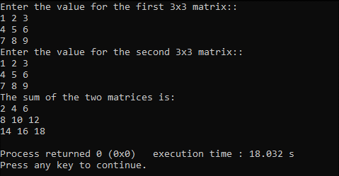

**Fig5. Output of program showing sum of two given matrices**